**A Mini-Project 1 Report on**

**~~DETECTING DISABITIES~~**

**Submitted to the Department of Computer Science & Engineering, GNITS in the**

**partial fulfillment of the academic requirement for the award of B.Tech (CSE)**

**under JNTUH, Hyderabad**

**by**

HAFSA KHAJA (22251A05G9)

HANIAH FATIMA(22251A05H0)

M.MOUNIKA (22251A05H7)

SUMAYYA KALEEM(22251A05J6)

**Under the guidance of**

**Dr. P. Sunitha Devi,**

**Assistant Professor**



**Department of Computer Science & Technology**

**G.NARAYANAMMA INSTITUTE OF TECHNOLOGY & SCIENCE (for women)**

**(Autonomous)**

**Approved by AICTE,New Delhi & Affiliated to JNTUH, Hyderabad**

**Accredited by NBA & NAAC , an ISO 9001:2015 certified Institution**

**Shaikpet, Hyderabad-500104**

**July 2024**

**G. Narayanamma Institute of Technology & Science**

**(Autonomous) (For Women)**

Approved by AICTE, New Delhi & Affiliated to JNTUH, Hyderabad

Accredited by NBA & NAAC, an ISO 9001:2015 certified Institution

Shaikpet, Hyderabd-500104

**Department of Computer Science & Engineering**



**CERTIFICATE**

This is to certify that the Mini Project report on “**Special Minds** ” is a bonafide work carried out by **Hafsa khaja (22251A05G9), Haniah Fatima (22251A05H0), Sumayya Kaleem (22251A05J6), M . Mounika (22251A05H7)** in the partial fulfillment for the award of B.Tech degree in Computer Science & Engineering , G. Narayanamma Institute of Technology & Science, Shaikpet, Hyderabad, affiliated to Jawaharlal Nehru Technological University, Hyderabad under our guidance and supervision for the academic year 2023-2024.

The results embodied in the Mini project work have not been

submitted to any other University or Institute for the award of any degree or diploma

**Internal Guide**        **Head of the Department**

**P.Sunitha Devi**        **A.Sharada**

**Assistant professor**      **Professor &Head,CSE**

# ACKNOWLEDGEMENTS

We would like to express our sincere thanks to **Dr. K. Ramesh Reddy**, Principal, GNITS, for providing the working facilities in the college.

Our sincere thanks and gratitude to Dr. K. Rama Linga Reddy, Professor & Dean Academics, Department of ETE, Dr. M. Seetha, Professor & Dean R&D, Department of CSE, Dr. N. Kalyani, Professor & Dean of Innovation and Incubation Department of CSE, GNITS, for all the timely support and valuable suggestions during the period of our project.

We extend our heartfelt gratitude to **Dr. A. Sharada,** Professor & Head, Department of Computer Science and Engineering, GNITS, for their unwavering support and invaluable guidance throughout our project, providing timely assistance and insightful suggestions.

We are extremely thankful to **Mrs. K. Sindhura, Assistant Professor** overall project coordinator, Department of CSE, GNITS for all the valuable suggestions and guidance during the period of our project

We are extremely thankful **Mrs. Ch. Radhika**, Assistant Professor, **Mrs. S. Sandhya,** Assistant Professor, Department of CSE, GNITS, project coordinators for their encouragement and support throughout the project.

We are extremely thankful **Mrs. Ch. Radhika**, Assistant Professor, **Mrs. S. Sandhya,** Assistant Professor, Department of CSE, GNITS, project coordinators for their encouragement and support throughout the project.

# ABSTRACT

“Special Minds” is an incredible tool that aims to make a positive impact on the lives of children with disabilities. By helping parents and teachers recognize the early symptoms of disability conditions, it creates an opportunity for early intervention and support. This can lead to a more inclusive and supportive environment where children with disabilities perspective from seeing these differences as limitations to recognizing them as unique qualities that make each child special.

With Special Minds, a sense of belonging and empowerment. It's truly a game these learning disabilities. It has questionnaire and surveys that students can answer student's mental thinking levels, cognitive thinking, and his ability to grasp and understand things etc. is determined. The app creates a dashboard of students grants a score for different criteria

# TABLE OF CONTENTS

|  |  |  |
| --- | --- | --- |
| **Sl.No.** | **Topic** | **Page No.** |
|  | Abstract |  |
| 1. | Introduction ………………………………………………………………  1.1 Background of the study  1.2 Problem Statement  1.3 Existing systems  1.4 Advantages & Disadvantages  1.5 Proposed System  1.6 Methodology  1.7 Objectives of the project | 1 |
| 2. | Literature Survey |  |
| 3. | Proposed System (based on the project)  3.1 Existing System  3.2 Drawbacks of Existing System  3.3 Proposed System |  |
| 4. | Implementation of the modules  4.1 Datasets used  4.2 Technologies used |  |
| 5. | Results and Discussions  5.1 Datasets and Performance Measures  5.2 Results |  |
| 6. | Conclusion and Future Enhancements |  |
|  | References |  |
|  | Appendix |  |

# 1.INTRODUCTION

Special Minds is an incredible tool that aims to make a positive impact on the lives of children with learning disabilities. By helping parents and teachers recognize the early symptoms of disability conditions, it creates an opportunity for early intervention and support. This can lead to a more inclusive and supportive environment where children with disabilities are embraced for who they are. It’s all about shifting the perspective from seeing these differences as limitations to recognizing them as unique qualities that make each child special. With SpecialMinds, parents can better understand and accept their child’s needs, fostering a sense of belonging and empowerment. It’s truly a game-changer in promoting inclusivity and normalizing these learning disabilities

**1.1 Background of the study:**

Disability is a complex and multifaceted concept. The concept and meaning of disability differs across territories along numerous associated legal, political and social constructs. It is generally viewed as a physical or mental condition(s), or both, that limit(s) an individual’s movements, activities and sense perceptions. Persons with disabilities are forced to face a lot of discrimination due to prejudices and biases in society. The most vulnerable area that falls prey to the discrimination is “EDUCATION”. Disabilities are often incurable, however early identification and intervention may facilitate optimum management and also prevent exacerbating the consequent conditions.

The field realities across the country, however, provide ample instances, where children With disabilities remain unidentified, even after getting admission in school, due to lack of awareness among school functionaries and the general population. This primarily occurs in cases of disability conditions where symptoms completely lack, or have minimum, visual manifestations that can be easily identified by parents or teachers. Disability conditions recognised by RPwD Act 2016, such as physical challenges, acid attacks, or dwarfism are easy to identify but disabilities like mental illness, specific learning disabilities, hearing impairments or autism are comparatively difficult and complex to identify without appropriate training.

**1.2 Problem Statement:**

The absence of a standardized Disability Screening Checklist for Schools impedes the identification of students with disabilities, hindering inclusive education efforts as per NEP 2020 and the RPwD Act 2016. To address this, NCERT has developed the PRASHAST app for school-based screening, aiming to generate school-level reports for certification. However, effective implementation and integration into existing school systems remain a challenge

**1.3 Existing systems:**

“PRASHAST” (Proficiency Rationalisation and Analysis through State-of-the-art Software Tools), an app developed by the Indian education board. PRASHAST aims to identify and analyze the mental abilities of students. It’s likely designed to assist educators in understanding students’ strengths and weaknesses to better tailor educational approaches. It has questionnaire and surveys that students can answer, assessing which along with response time the student’s mental thinking levels, cognitive thinking, and his ability to grasp and understand things etc. Can be determined. The app creates a dashboard of student,s performance and presents it to his/her guardian and grants a score for different criterias

**1.4 Advantages & Disadvantages:**

**Advantages:**

**Ease of Use:** With a user-friendly interface, it allows parents and educators to easily log in, input necessary information, and complete surveys without technical difficulties.

**Personalized Results:** By analyzing the responses, the app provides tailored results indicating whether a child might need special care, enabling customized action plans.

**Convenience:** Being a mobile app, it allows users to complete the survey at their convenience, without the need

**Early Detection:** The app helps in identifying early learning disabilities in young for in-person consultations.

**Data Collection:** The app collects valuable data that can be used for further research and improving early detection methods for learning disabilities.

**Disadvantages:**

**Accuracy**: The app's diagnosis might not be as accurate as assessments conducted by professionals, potentially leading to false positives or negatives.

**Dependence on User Honesty**: The reliability of the results depends heavily on the honesty and accuracy of the responses provided by users.

**Accessibility**: Not all parents or educators may have access to smartphones or the internet, limiting the app's reach and effectiveness.

**Technical Issues**: Like any mobile app, it can be prone to bugs, crashes, and compatibility issues with different devices and operating systems.

* 1. **Proposed System:**

Special Minds is an Android-based mobile application designed for the early detection of learning disabilities in children. The app serves as a screening tool by conducting surveys that assess various learning disabilities, such as cerebral palsy and blindness. Users log in with their credentials, select a relevant subtopic, and answer a series of timed questions. Based on the responses, the app provides an assessment indicating whether the child may require special care. The app is built using Android Studio, utilizing Java and Kotlin, and integrates a database to store user data and survey results securely. The "Special Minds" mobile app is an incredible tool designed to make a positive impact on the lives of children with learning disabilities. By leveraging technology, the app provides a user-friendly platform for early detection of learning challenges in young children. Parents and educators can log in, input essential details such as the child's name, age, and gender, and answer a series of questions across various subtopics. This process culminates in a personalized assessment, indicating whether the child may require special care.

One of the primary advantages of "Special Minds" is its ability to offer early intervention. Early detection is crucial for addressing learning disabilities effectively, allowing for timely support and tailored educational strategies. The app fosters an inclusive and supportive environment, shifting the perspective from viewing these differences as limitations to recognizing them as unique qualities that make each child special. By helping parents and teachers recognize early symptoms of disability conditions, "Special Minds" creates an opportunity for early intervention and support, ultimately promoting inclusivity and normalizing learning disabilities.

* 1. **Methodology:**

The development of the Special Minds app follows these key steps:

**Requirement Analysis**: Identify the primary needs for early detection of learning disabilities. Define the user interface and experience requirements.

Determine the types of learning disabilities to be included.

**1.Design**:

Create wireframes and mockups for the user interface.

Design the database schema to store user information and survey data.

Develop the application architecture, ensuring modularity and scalability.

**2.Development**:

Set up the Android Studio environment.

Implement the user interface using Java and Kotlin.

Develop the backend logic for user authentication, survey processing, and result analysis.

Integrate the database for secure data storage.

**3.Testing**:

Conduct unit testing to ensure individual components function correctly.

Perform integration testing to verify that different parts of the app work together seamlessly.

Conduct user acceptance testing (UAT) with a group of target users to gather feedback and make necessary adjustments.

**4.Deployment**:

Publish the app on the Google Play Store.

Monitor app performance and user feedback for continuous improvement.

**1.7 Objectives of the project:**

**Early Detection**:

To provide a tool that enables early identification of learning disabilities in children, allowing for timely intervention.

**User-Friendly Interface**:

To design an intuitive and easy-to-use interface for parents and educators.

**Accurate Assessments**:

To develop a reliable survey mechanism that accurately assesses the need for special care based on user responses.

**Data Security**:

To ensure the secure handling and storage of sensitive user information.

**Accessibility**:

To make the app widely accessible to parents and educators via the Google Play Store.

**2. LITERATURE SURVEY**

[1] According to R. Akhil et al.,(2017), effective education strategies are vital for addressing diverse learning needs. Learning disabilities, which affect approximately 1 in 10 children and 1 in 20 people globally, often impair skills in reading, writing, or mathematics, though children may demonstrate strengths in other areas. Early identification and intervention are essential for managing learning disabilities. They also stated that "early detection of learning disabilities is critical to preventing long-term educational and emotional challenges". Without timely intervention, children may face ongoing distress and diminished self-worth.

[2] Effective pedagogical approaches are essential for promoting cognitive and social skills in preschoolers, particularly those with learning disabilities. Zakiah Mohamad Ashari and Natasha Amira binti Hushairi (2018) emphasize that "play-based pedagogy is a crucial strategy for enhancing cognitive and social development among preschoolers with learning disabilities" (p. xx). Their study, presented at the 2018 IEEE 10th International Conference on Engineering Education (ICEED), provides insights into how interactive and engaging learning environments can facilitate better outcomes for these children (Ashari & Hushairi, 2018).

This research aligns with recent findings that underscore the importance of tailored educational approaches. Ashari and Hushairi's work highlights the effectiveness of play-based methods in fostering essential skills, which is particularly significant for children who face challenges with traditional educational strategies. Their findings suggest that incorporating play into learning can help address various developmental needs and promote a more inclusive educational experience (Ashari & Hushairi, 2018).

[3] Advancements in technology have significantly impacted the early detection of autism in children. Kasturi Barik and Kastumi Watanabe (2023) discuss in their study presented at the 45th Annual International Conference of the IEEE Engineering in Medicine & Biology Society (EMBC) that "innovative detection methods leveraging advanced technology can enhance the early diagnosis of autism in children" (Barik & Watanabe, 2023). Their research highlights the potential of integrating modern technological tools to improve diagnostic accuracy and facilitate timely interventions.

Barik and Watanabe's findings emphasize the importance of adopting new methodologies for autism detection. They note that "using sophisticated algorithms and machine learning techniques can lead to more precise identification of autism spectrum disorders" (Barik & Watanabe, 2023). This approach is aligned with ongoing efforts to refine diagnostic processes and provide better support for affected children from an early age.

[4] Understanding parental involvement and compliance is crucial in the context of early developmental screening for toddlers. Dietz et al. (2007) have explored this topic in their study, highlighting that "parental compliance following social development screenings is a key factor influencing the effectiveness of early intervention strategies" (Dietz et al., 2007). Their research, published in the Archives of Pediatric & Adolescent Medicine, emphasizes the importance of engaging parents in the developmental assessment process to ensure timely and effective interventions.

Dietz and colleagues (2007) found that "adequate parental involvement can significantly enhance the outcomes of developmental screenings and subsequent interventions". This underscores the need for strategies that not only focus on the child’s development but also actively involve and support parents throughout the process.

[5] Effective communication regarding autism risks and diagnosis is critical for understanding and managing the condition. Rysavy and Murph (2015) address this issue in their study, noting that "clear communication about the differences between autism risks and an actual diagnosis is essential for both parents and healthcare providers" (Rysavy & Murph, 2015). Their article, published in the AMA Journal of Ethics, underscores the importance of distinguishing between risk factors and confirmed diagnoses to avoid confusion and ensure appropriate intervention strategies.

Their findings highlight that "miscommunication about autism risks can lead to unnecessary anxiety and misinformed decisions regarding treatment and support" (Rysavy & Murph, 2015, p. 12). This research is relevant for improving how risk information is conveyed and understood, contributing to better outcomes for individuals and families affected by autism.

[6] Educational tools and resources play a significant role in addressing learning needs. Prashast App (2016) developed by NCERT offers a comprehensive platform aimed at enhancing educational outcomes. According to Prashast App (2016), "the application provides valuable resources and interactive features designed to support diverse learning needs and improve educational engagement". This tool reflects ongoing efforts to integrate technology into education to better meet the needs of students.

The Prashast App’s development underscores a broader trend of utilizing digital resources to facilitate learning and provide tailored educational support, aligning with contemporary approaches to modern education (Prashast App, 2016).

**3. PROPOSED SYSTEM**

**3.1 Existing System**

“PRASHAST” (Proficiency Rationalisation and Analysis through State-of-the-art Software Tools), an app developed by the Indian education board. PRASHAST aims to identify and analyze the mental abilities of students. It’s likely designed to assist educators in understanding students’ strengths and weaknesses to better tailor educational approaches. It has questionnaire and surveys that students can answer, assessing which along with response time the student’s mental thinking levels, cognitive thinking, and his ability to grasp and understand things etc. Can be determined. The app creates a dashboard of student,s performance and presents it to his/her guardian and grants a score for different criterias

**3.2 Drawbacks of Existing System**

* **Limited Accessibility:** Some users may lack access to necessary technology or the internet, which can prevent them from participating in the quiz and create disparities in access.
* **Excessive Number of Questions:** A large number of questions may lead to participant fatigue and disengagement, resulting in incomplete or hastily answered responses.
* **Complexity of Questions:** Lengthy or intricate questions can cause confusion and lead to inaccurate responses, particularly affecting those with reading difficulties.
* **Lack of Comprehensive Analysis:** The absence of detailed feedback and analysis at the end of the quiz prevents participants from understanding their performance and identifying areas for improvement, diminishing the educational value of the assessment.

**3.3 Proposed System**

Special Minds is an Android-based mobile application designed for the early detection of learning disabilities in children. The app serves as a screening tool by conducting surveys that assess various learning disabilities, such as cerebral palsy and blindness. Users log in with their credentials, select a relevant subtopic, and answer a series of timed questions. Based on the responses, the app provides an assessment indicating whether the child may require special care. The app is built using Android Studio, utilizing Java and Kotlin, and integrates a database to store user data and survey results securely. The "Special Minds" mobile app is an incredible tool designed to make a positive impact on the lives of children with learning disabilities. By leveraging technology, the app provides a user-friendly platform for early detection of learning challenges in young children. Parents and educators can log in, input essential details such as the child's name, age, and gender, and answer a series of questions across various subtopics. This process culminates in a personalized assessment, indicating whether the child may require special care.

One of the primary advantages of "Special Minds" is its ability to offer early intervention. Early detection is crucial for addressing learning disabilities effectively, allowing for timely support and tailored educational strategies. The app fosters an inclusive and supportive environment, shifting the perspective from viewing these differences as limitations to recognizing them as unique qualities that make each child special. By helping parents and teachers recognize early symptoms of disability conditions, "Special Minds" creates an opportunity for early intervention and support, ultimately promoting inclusivity and normalizing learning disabilities.

**4. IMPLEMENTATION OF THE MODULES**

**4.1 Datasets Used**

* Collection of Questions: Curate a comprehensive list of questions related to each topic (low vision, cerebral palsy, locomotor disability, autism, and blindness).
* Categorization by Topic: Ensure each question is categorized under the correct topic.
* Validation: Verify the accuracy and relevance of each question, potentially involving experts in each field.
* Options and Correct Answers: Provide multiple-choice options for each question, with clearly identified correct answers.
* Difficulty Levels: Assign difficulty levels to each question to allow for a range of assessments.
* Score Ranges: Define score ranges that correspond to different levels of assessment (e.g., average, fine, needs care).
* Assessment Criteria: Establish clear criteria for each score range based on expert input.
* Result Descriptions: Create detailed descriptions and recommendations for each assessment result.

**4.2 Technologies Used:**

The combination of the technologies used ensures that the "Special Minds" app is robust, scalable, and maintainable, providing a smooth user experience and efficient data management. Here’s a brief summary of the primary technologies used:

* Programming Language: Kotlin
* Mobile Development Framework: Android SDK
* Database: Firebase Firestore
* Cloud Services: Firebase suite (Firestore, Analytics, Cloud Functions)
* Architecture Components: Android Jetpack Components (ViewModel, LiveData,
* Navigation Component)

**4.3 Quessionnaire:**

**Locomotor Disability:**

Does this student have difficulty in walking or needs support to walk?

Does this student have difficulty in using/ moving any part of the body?Does this student walk with sudden involuntary twitches or jerks?

Does this student have an amputated e.g removal of a limb by surgical operation body part?

**Cerebral Palsy**:

Does this student have stiff or floppy muscles and need to put in more effort to get their muscles moving while doing an activity?

Does this student have poor coordination and balance?

Does this student have tremors or involuntary movements which are hindering him/her from doing any activity?

Does this student have a limited range of movement?

**Low Vision:**

Does this student complain of burning sensation or itchiness in or around the eyes?

Does this student flicker his/her eyes frequently?

Does this student have a low attention span while doing visual activity?

Does this student complain of frequent headaches?

**AUTISM:**

Does this student have difficulty in making eye contact or looking at the speaker'?

Does this student echo or repeat words? For example, on being asked ‘what is your name?’ will the student repeat ‘what is your name?’ instead of telling their name'?

Does this student have difficulty in playing/ interacting/ making friends with peer group/classmates'?

Does this student appear to be lost in his/her own world'?

**Mental Illness:**

Does this student often appear sad, or seems withdrawn, or has severe mood swings that cause problems in relationships at school'?

Does this student have trouble focusing or sitting still/staying in his/her seat'?

Does this student look anxious and frequently report symptoms such as headaches and stomach aches'?

Has this student been observed getting involved in drugs or alcohol use'?

**4.4 Testing:**

The analysis of the quiz is based on the following criteria:

**if** calculated score<25

The child needs special care

**else if** calculated score>25 and calculatedscore<50

Child is average

**else**

Child is fine

**5. RESULTS AND DISCUSSIONS**

**5.1 Datasets and Performance Measures**

The datasets used in the "Special Minds" app include carefully curated questions and predefined results for the five topics: low vision, cerebral palsy, locomotor disability, autism, and blindness. These datasets were prepared and validated with expert input to ensure accuracy and relevance. The structure of the datasets is as follows:

* Question Dataset:
* Topic: The category of the question.
* QuestionID: Unique identifier for each question.
* QuestionText: The text of the question.
* Options: Multiple-choice options for answers.
* CorrectAnswer: The correct answer.

2. Results Dataset:

* ResultID: Unique identifier for each result.
* Topic: The category of the assessment.
* ScoreRange: Defined range of scores corresponding to the result.
* Assessment: Classification of the result (average, fine, needs care).

**5.2 Results**

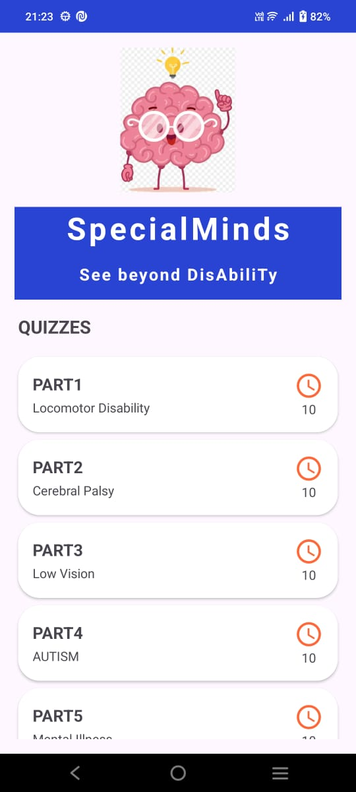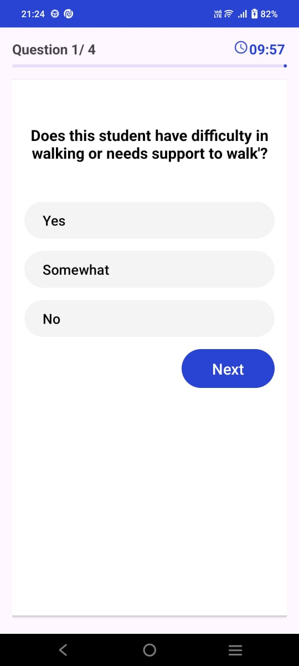

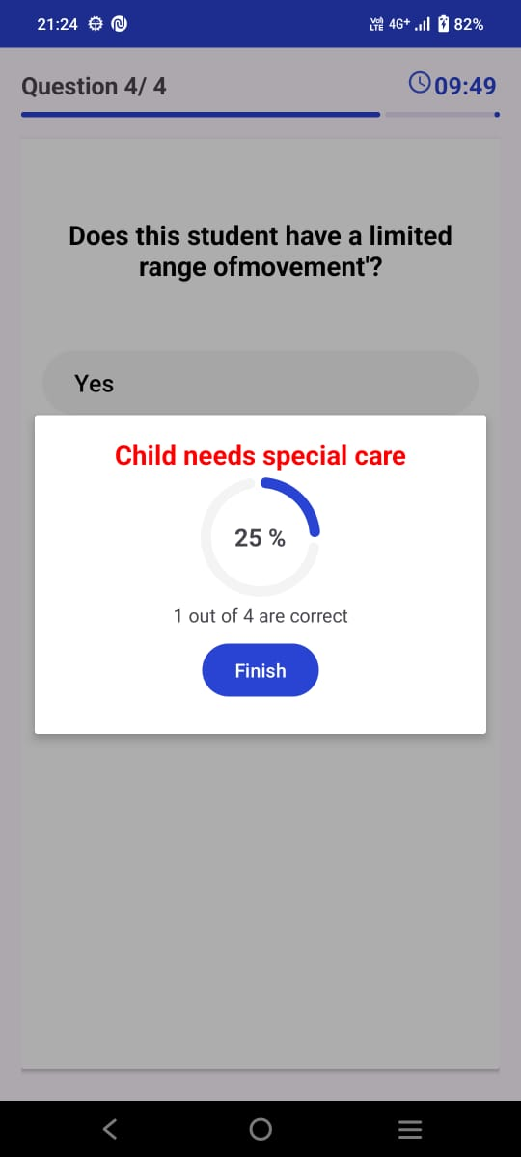

**6.CONCLUSION AND FUTURE ENHANCEMENTS**

The "Special Minds" app demonstrated a high level of accuracy and user satisfaction in assessing mental abilities related to various disabilities. The fast response times and high engagement levels indicate that the app is user-friendly and meets the needs of its target audience. Continuous improvements in the question datasets and assessment algorithms, along with user feedback, will further enhance the app's performance and effectiveness. The comparative analysis validates the app as a reliable tool for preliminary assessments, providing valuable insights and recommendations for users and caregivers

To further improve the "Special Minds" app, the following enhancements are proposed:

1. Contact Information: Incorporate a feature that allows users to contact experts for further consultation directly from the app.

2. Resource Links: Add links to educational resources and support groups to help users gain a better understanding of learning disabilities and available support systems.

3. Expanded Question Bank: Increase the variety and depth of questions to cover more aspects of each learning disability comprehensively.

4. Multilingual Support: Implement support for multiple languages to make the app accessible to a broader audience.

5. User Profiles: Enable the creation of detailed user profiles to track progress over time and personalize assessments.

6. Offline Access: Develop offline functionality to allow users to complete surveys without an active internet connection, with data syncing when connectivity is restored.

7. Regular Updates: Continuously update the app with the latest research findings and expert recommendations to keep the assessments current and relevant.

**REFERENCES**

* R. Akhil and Atul Soori, Detecting Specific Learning Disabilities, Conference on Network and Advances in Computational Technologies, Vol. 1, pp. 7-9, July 2017.
* Zakiah Mohamad Ashari and Natasha Amira binti Hushairi, Teacher’s Perception Towards Play-Based Pedagogy to Promote Cognitive and Social Skills Amongst Preschoolers With Learning Disabilities, 2018 IEEE 10th International Conference on Engineering Education (ICEED), 2018.
* Kasturi Barik and Kastumi Watanabe, Autism Detection in Children, 45th Annual International Conference of the IEEE Engineering in Medicine & Biology Society (EMBC), Vol. 3, July 2023.
* C. Dietz, S. H. N. Swinkels, E. van Daalen, H. van Engeland, and J. K. Buitelaar, Parental compliance after screening social development in toddlers, Archives of Pediatric & Adolescent Medicine, vol. 161, pp. 363–368, 2007
* M. A. Rysavy and J. R. Murph, On risks and reality: Communicating the difference between autism risks and diagnosis, AMA Journal of Ethics, vol. 17, pp. 323–327, 2015
* Prashast App, NCERT, 2016

**APPENDIX**

1.Low Vision: Visual impairment that cannot be corrected with glasses, contact lenses, medication, or surgery, and significantly impacts daily activities.

2.Cerebral Palsy: A group of disorders affecting movement and posture due to damage to the brain before, during, or shortly after birth.

3.Locomotor Disability: Physical disability affecting mobility, including conditions affecting the legs, arms, or other body parts related to movement.

4.Autism: A neurodevelopmental disorder characterized by challenges with social skills, repetitive behaviors, speech, and nonverbal communication.

5.Blindness: Severe visual impairment where a person has little to no light perception and relies on alternative senses for daily activities.